





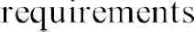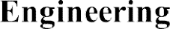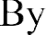

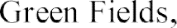







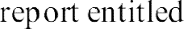

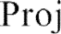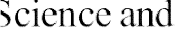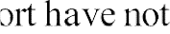









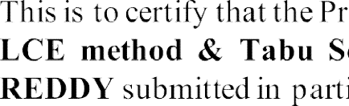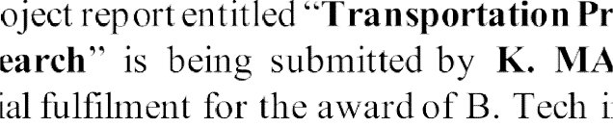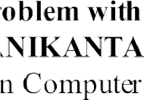

 

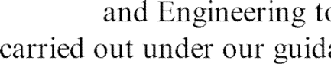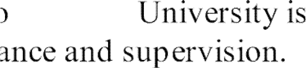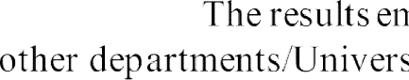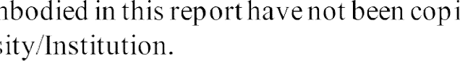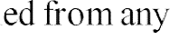





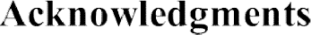

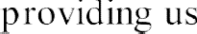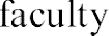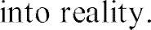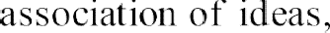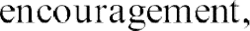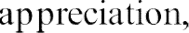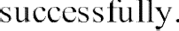

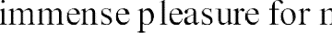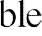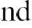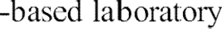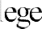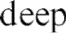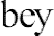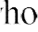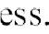



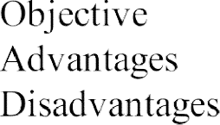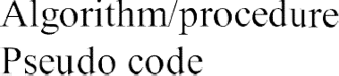







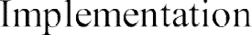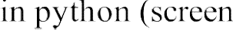



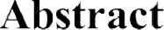





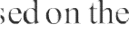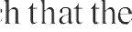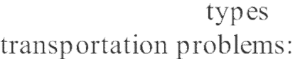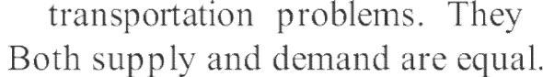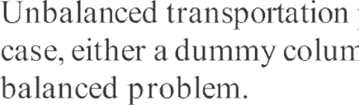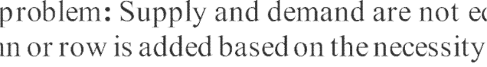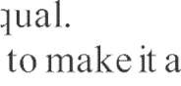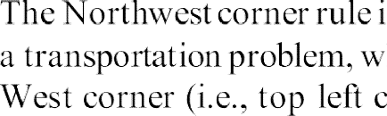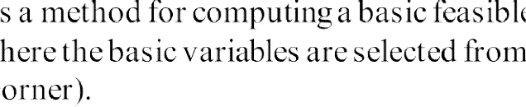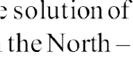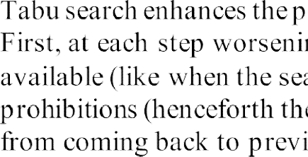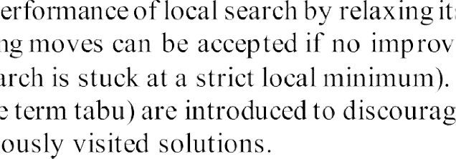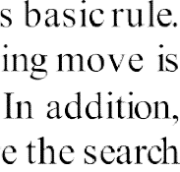



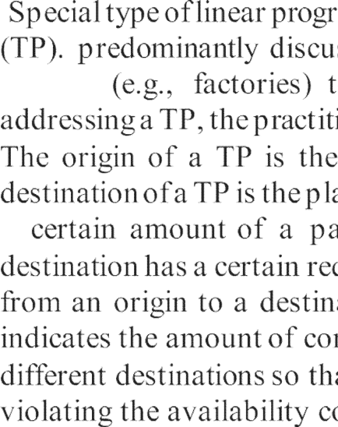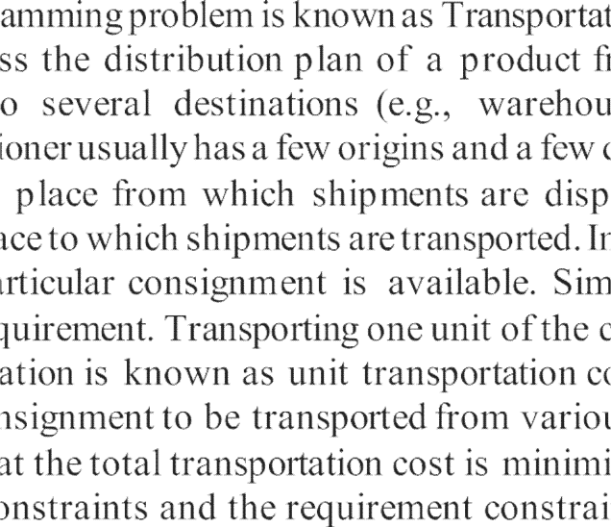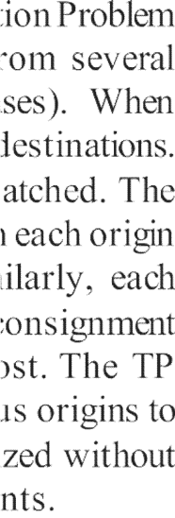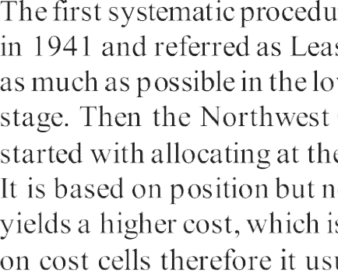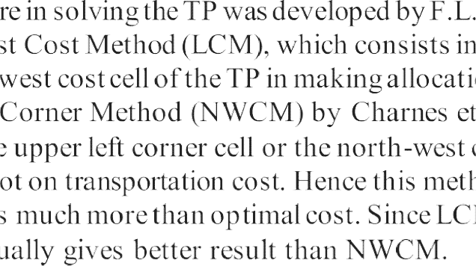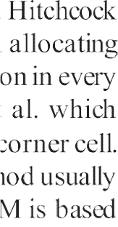





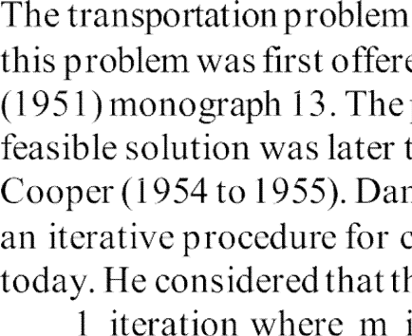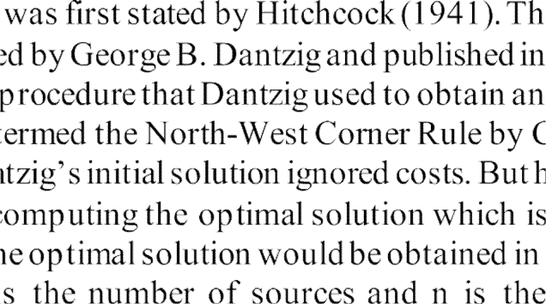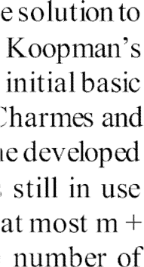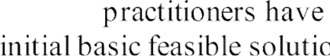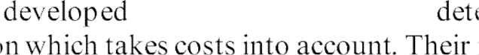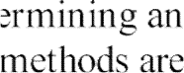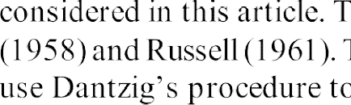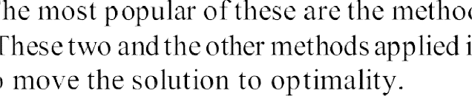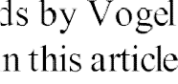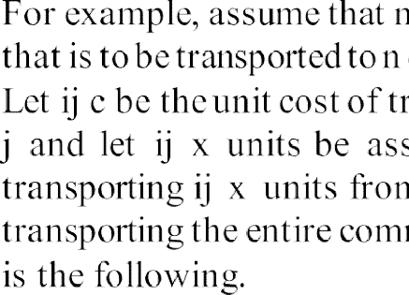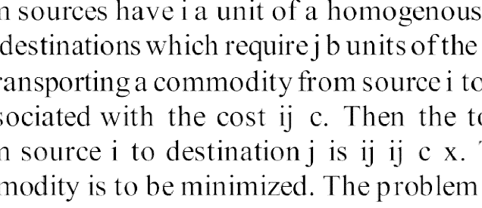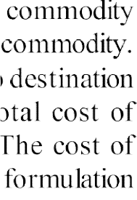

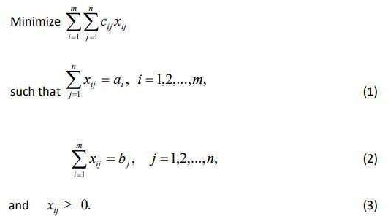

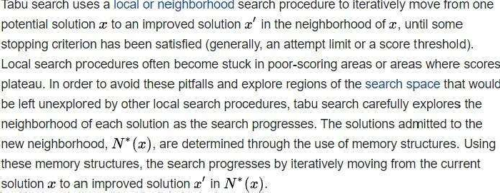

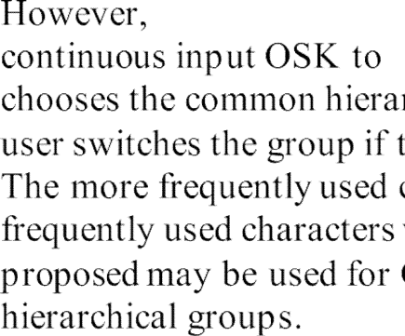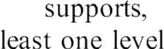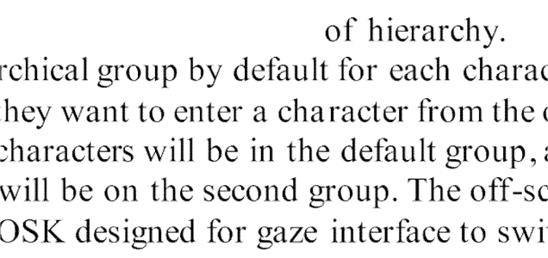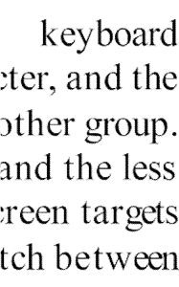

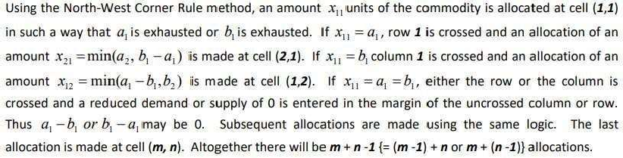

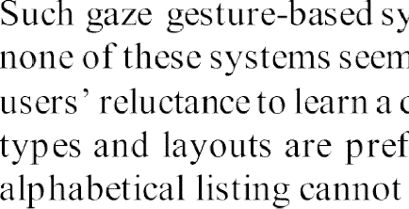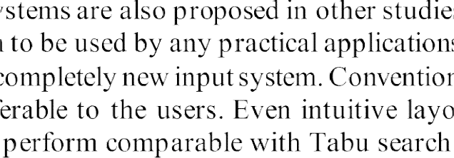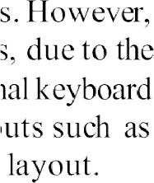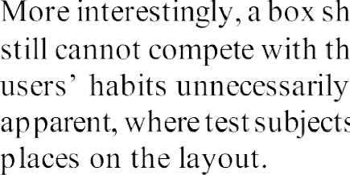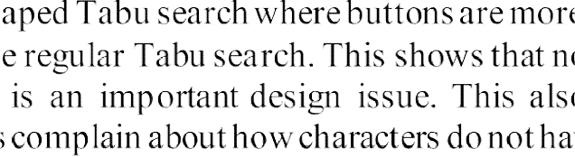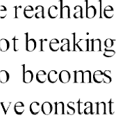



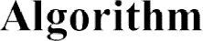

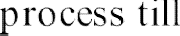

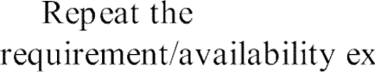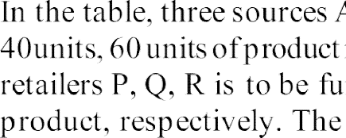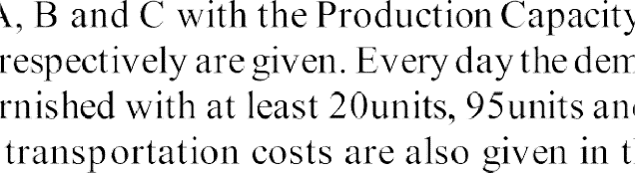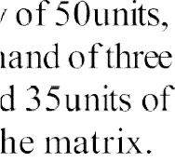

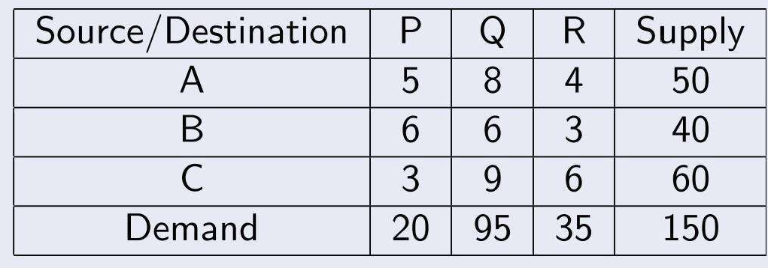

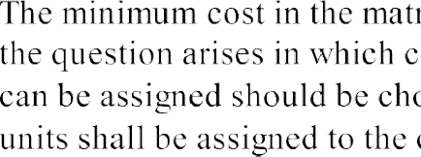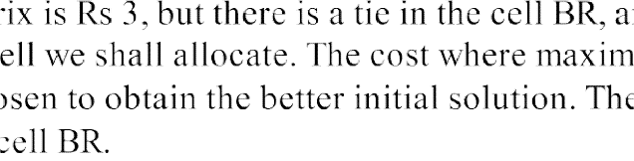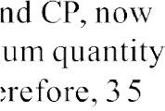

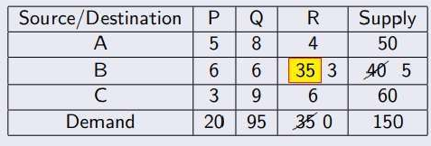



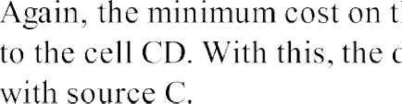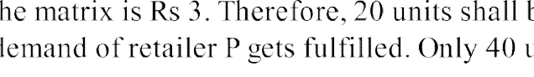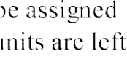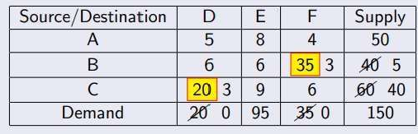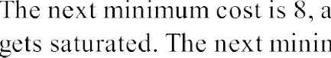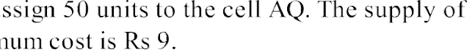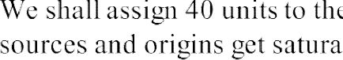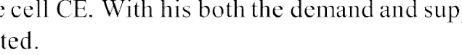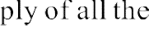

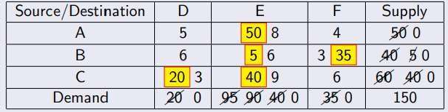

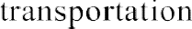

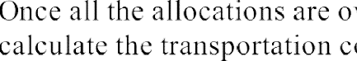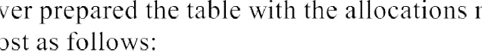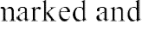

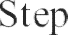

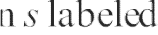

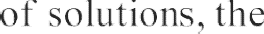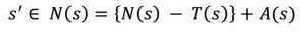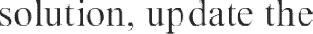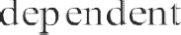

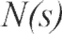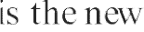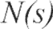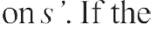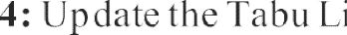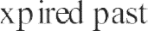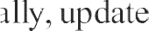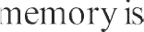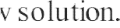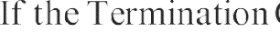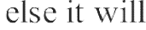





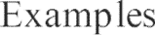



 

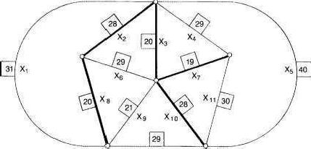





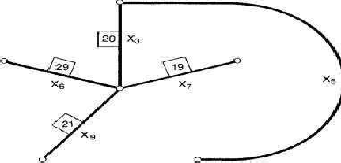

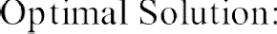





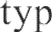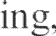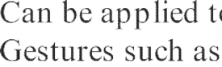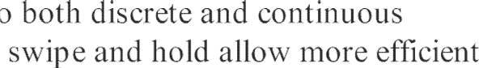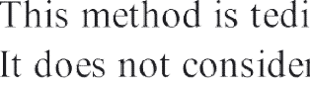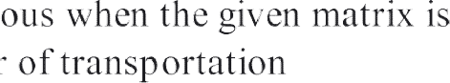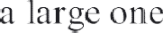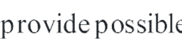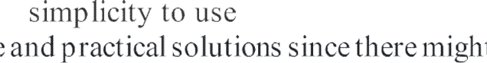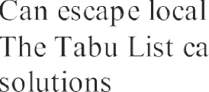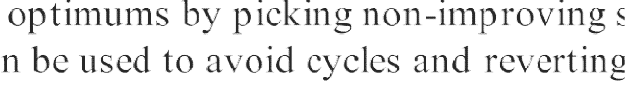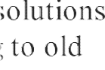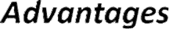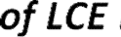

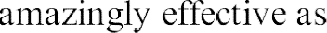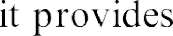

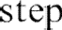



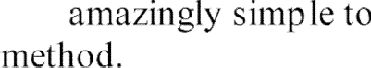



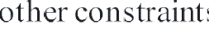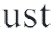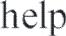





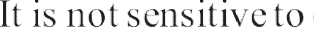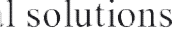

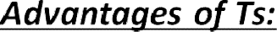

  

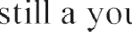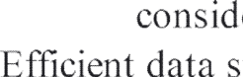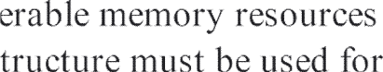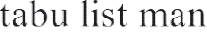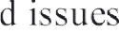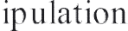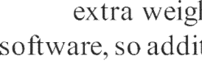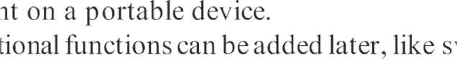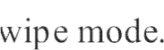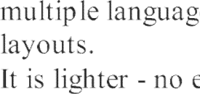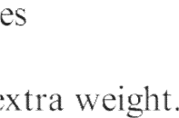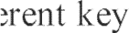

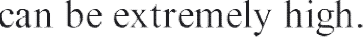



    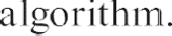

  





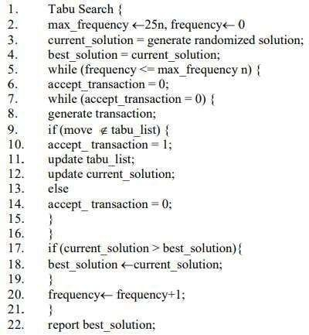



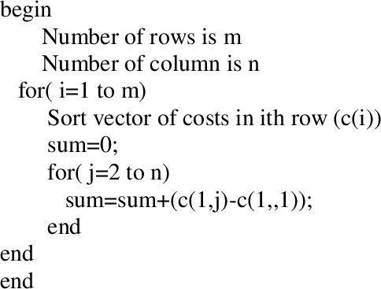



import numpy as np

"""

#transportation problem input

supply = list(map(int,input("Enter the supply (give space between each value): ").strip().split()))

demand = list(map(int,input("Enter the demand (give space between each value): ").strip().split()))

cost = list(map(int,input("Enter the cost (give space between each value): ").strip().split())) cost = (np.asarray(cost)).reshape((n,m))

c = cost.copy().tolist() """

#problem statement supply = [11,13,19] #i demand = [6,10,12,15] #j c = [[21,16,15,3],

[17,18,14,23],

[32,27,18,41]]

tot_cost = 0

print("\nTRANSPORTATION PROMLEM IS AS FOLLOWS

:\nsupply=",supply,"\ndemand=",demand,"\ncost=",c,

"\n\n\nITERATIONS OF COST MINIMUM METHOD ARE AS FOLLOWS :")

#checked if balanced problem

if (sum(supply)!=sum(demand)):

print("\nIts not a balanced problem. Please enter values again.") else:

while(sum(demand)!=0): n,m = np.shape(c) mini = np.amin(c)

#find minimum cij i=0

j=0

for a in range(n): for b in range(m):

if(c[a][b] == mini): i=a

j=b break

if (supply[i]<demand[j]): k=supply[i]

demand[j]= demand[j]-supply[i] supply[i]=0

elif (supply[i]>demand[j]): k=demand[j]

supply[i]= supply[i]-demand[j] demand[j]=0

else:

k=demand[j] supply[i]=0 demand[j]=0

tot_cost = tot_cost + (mini*k) if (supply[i]==0):

c = np.delete(c, i, 0)

supply.pop(i)

if (demand[j]==0):

c = np.delete(c, j, 1) demand.pop(j)

print("minimum=",mini,"\nupdated supply=",supply,"\nupdated demand=",demand,"\nupdated cost=\n",c,"\n")

print("\n\nRESULT :\nTherefore total transportation cost is Rs.",tot_cost)

output:

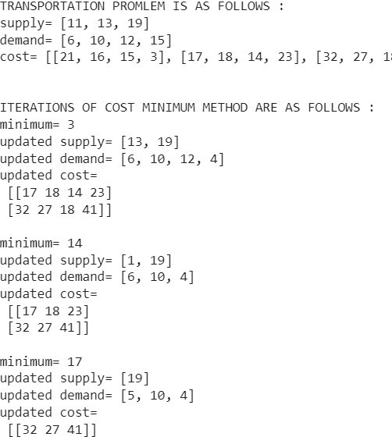

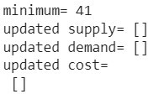

Code for ts:

import pandas as pd

import random as rd

from itertools import combinations import math

class TS():

def init__(self, Path, seed, tabu_tenure): self.Path = Path

self.seed = seed self.tabu_tenure = tabu_tenure

self.instance_dict = self.input_data() self.Initial_solution = self.get_InitialSolution() self.tabu_str, self.Best_solution,

self.Best_objvalue = self.TSearch() def input_data(self):

'''Takes the path of the excel file of the SMTWTP instances.

Returns a dict of jobs number as Key and weight, processing time (hours) and due date (hours) as values.

'''

return pd.read_excel(self.Path, names=['Job', 'weight', "processing_time", "due_date"],

index_col=0).to_dict('index')

def get_tabuestructure(self): '''Takes a dict (input data)

Returns a dict of tabu attributes(pair of jobs that are swapped) as keys and [tabu_time, MoveValue]

'''

dict = {}

for swap in combinations(self.instance_dict.keys(),

2):

dict[swap] = {'tabu_time': 0, 'MoveValue': 0} return dict

def get_InitialSolution(self, show=False):

n_jobs = len(self.instance_dict) # Number of jobs # Producing a random schedule of jobs initial_solution = list(range(1, n_jobs+1)) rd.seed(self.seed)

rd.shuffle(initial_solution) if show == True:

print("initial Random Solution:

{}".format(initial_solution)) return initial_solution

def Objfun(self, solution, show = False):

'''Takes a set of scheduled jobs, dict (input data) Return the objective function value of the solution '''

dict = self.instance_dict t = 0 #starting time objfun_value = 0

for job in solution:

C_i = t + dict[job]["processing_time"] #

Completion time

d_i = dict[job]["due_date"] # due date of the

job job

T_i = max(0, C_i - d_i) #tardiness for the

W_i = dict[job]["weight"] # job's weight objfun_value += W_i * T_i

t = C_i

if show == True:

print("\n","#"*8, "The Objective function value

for {} solution schedule is: {}".format(solution

,objfun_value),"#"*8)

return objfun_value

def SwapMove(self, solution, i ,j): '''Takes a list (solution)

returns a new neighbor solution with i, j swapped '''

solution = solution.copy() # job index in the solution:

i_index = solution.index(i) j_index = solution.index(j) #Swap

solution[i_index], solution[j_index] = solution[j_index], solution[i_index]

return solution def TSearch(self):

'''The implementation Tabu search algorithm with short-term memory and pair_swap as Tabu attribute.

'''

# Parameters:

tenure =self.tabu_tenure

tabu_structure = self.get_tabuestructure() #

Initialize the data structures

best_solution = self.Initial_solution best_objvalue = self.Objfun(best_solution) current_solution = self.Initial_solution current_objvalue = self.Objfun(current_solution) print("#"*30, "Short-term memory TS with Tabu

Tenure: {}\nInitial Solution: {}, Initial Objvalue:

{}".format(

tenure, current_solution, current_objvalue), "#"*30, sep='\n\n')

iter = 1

Terminate = 0

while Terminate < 100:

print('\n\n### iter {}### Current_Objvalue:

{}, Best_Objvalue: {}'.format(iter, current_objvalue,

best_objvalue))

# Searching the whole neighborhood of the current solution:

for move in tabu_structure: candidate_solution =

self.SwapMove(current_solution, move[0], move[1])

candidate_objvalue = self.Objfun(candidate_solution)

tabu_structure[move]['MoveValue'] =

candidate_objvalue

# Admissible move while True:

# select the move with the lowest ObjValue in the neighborhood (minimization)

best_move = min(tabu_structure, key =lambda x: tabu_structure[x]['MoveValue'])

MoveValue = tabu_structure[best_move]["MoveValue"]

tabu_time = tabu_structure[best_move]["tabu_time"]

# Not Tabu

if tabu_time < iter: # make the move current_solution =

self.SwapMove(current_solution, best_move[0], best_move[1]) current_objvalue =

self.Objfun(current_solution)

# Best Improving move

if MoveValue < best_objvalue: best_solution = current_solution best_objvalue = current_objvalue print(" best_move: {}, Objvalue:

{} => Best Improving => Admissible".format(best_move,

current_objvalue))

Terminate = 0 else:

print(" ##Termination: {}##

best_move: {}, Objvalue: {} => Least non-improving => " "Admissible".format(Terminate,best_move,

current_objvalue))

= iter + tenure

Terminate += 1

# update tabu_time for the move tabu_structure[best_move]['tabu_time']

iter += 1 break

# If tabu else:

# Aspiration

if MoveValue < best_objvalue: # make the move current_solution =

self.SwapMove(current_solution, best_move[0], best_move[1])

current_objvalue = self.Objfun(current_solution)

best_solution = current_solution best_objvalue = current_objvalue print(" best_move: {}, Objvalue:

{} => Aspiration => Admissible".format(best_move,

current_objvalue))

Terminate = 0

iter += 1 break

else:

tabu_structure[best_move]["MoveValue"] = float('inf')

print(" best_move: {}, Objvalue:

{} => Tabu => Inadmissible".format(best_move,

current_objvalue))

continue

print('#'*50 , "Performed iterations:

{}".format(iter), "Best found Solution: {} , Objvalue:

{}".format(best_solution,best_objvalue), sep="\n")

return tabu_structure, best_solution, best_objvalue test = TS(Path="Data_instances/Instance_10.xlsx", seed = 2012, tabu_tenure=3)

